### **1. Select Your Operating System (OS) and Install Windows 11**

1. **Visit the Windows 11 Download Page**: Open your browser and go to [Windows 11 Download](https://www.microsoft.com/software-download/windows11).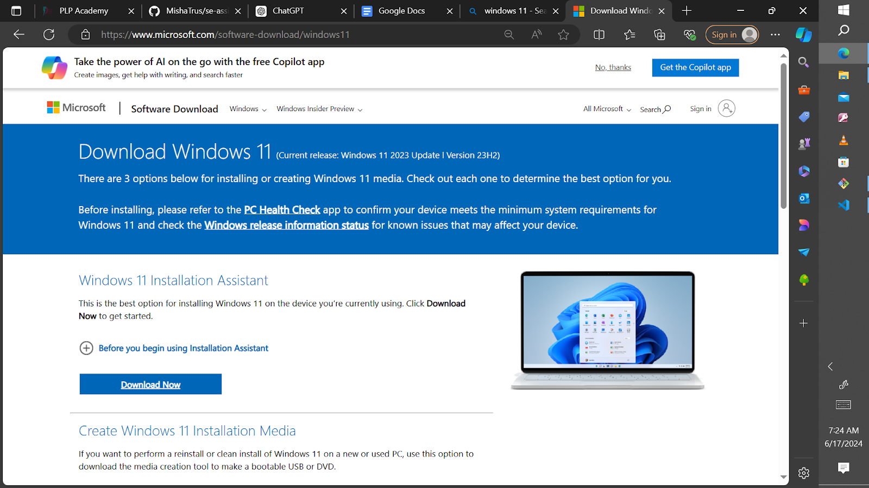
2. **Download the Installation Media**: Click on "Download Now" under "Create Windows 11 Installation Media".
3. **Run the Media Creation Tool**: Open the downloaded file and follow the instructions to create installation media.
4. **Install Windows 11**:
   * Insert the installation media (USB flash drive) into your computer and restart it.
   * Boot from the USB flash drive and follow the on-screen instructions to install Windows 11.
   * Enter your product key and select your preferences (language, time, etc.).
   * Choose "Custom: Install Windows only (advanced)" to perform a clean installation.

### **2. Install Visual Studio Code (VS Code)**

1. **Visit the Visual Studio Code Download Page**: Open your browser and go to [Visual Studio Code Download](https://code.visualstudio.com/Download).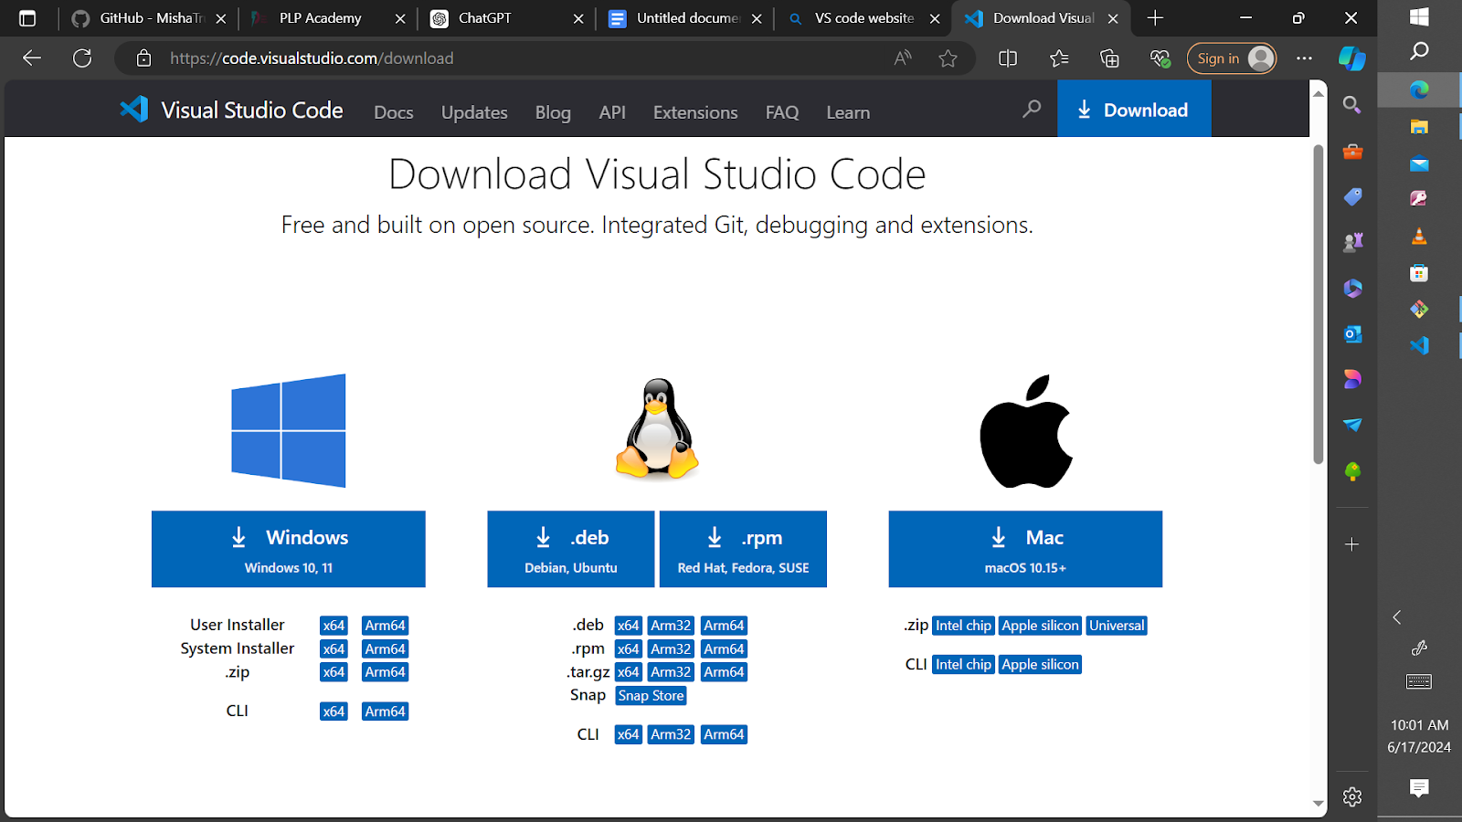
2. **Download the Installer**: Click on the download link for your operating system (Windows).
3. **Run the Installer**: Open the downloaded file and follow the installation instructions.
4. **Launch VS Code**: Open VS Code after installation and complete the initial setup.

### **3. Set Up Version Control System (Git and GitHub)**

1. **Install Git**:
   * Visit [Git Download](https://git-scm.com/downloads) and download the installer for your OS.
   * Run the installer and follow the setup instructions.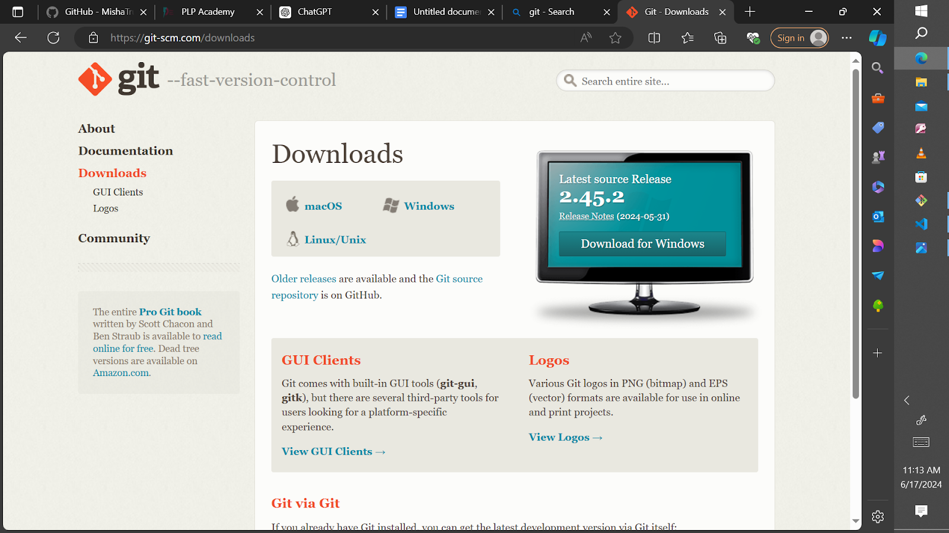

### **Creating a GitHub Account:**

1. **Go to GitHub:**

-Open your web browser and go to [GitHub](https://github.com/).

1. **Sign Up:**

-Click on "Sign up" and follow the prompts to create your GitHub account. You'll need to choose a username, enter your email address, and create a password.

1. **Verify Your Email:**

-GitHub will send you an email to verify your email address. Follow the instructions in the email to complete the verification process.

### **Initializing a Repository and Making Your First Commit:**

1. **Create a New Repository on GitHub:**

-Log in to your GitHub account.

-Click on the "+" icon in the upper-right corner of the page and select "New repository."

-Give your repository a name, optionally add a description, choose whether it should be public or private, and then click on "Create repository."

1. **Clone the Repository to Your Local Machine:**

-Open a terminal (or Git Bash on Windows).

-Use the git clone command to clone the repository to your local machine. Replace <repository-url> with the URL of the repository you just created on GitHub:

git clone <repository-url>

**Navigate into the Repository:**

-Change directory into the newly cloned repository:

cd <repository-name>

-Replace <repository-name> with the name of your repository.

**Create a New File or Modify an Existing File:**

-Use your preferred text editor or IDE to create a new file or modify an existing file within the repository.

**Add and Commit Changes:**

-After making changes, use the following commands to add and commit your changes:

git add . this command adds all changed files to the staging area.

git commit -m "Initial commit" this command commits the changes with a commit message describing the changes made.

**Push Changes to GitHub:**

Finally, push your changes to GitHub using the git push command:  
git push origin main

* This command pushes the committed changes from your local main branch to the remote repository on GitHub.

### **4. Install Python**

1. **Visit the Python Download Page**: Open your browser and go to [Python Downloads](https://www.python.org/downloads/).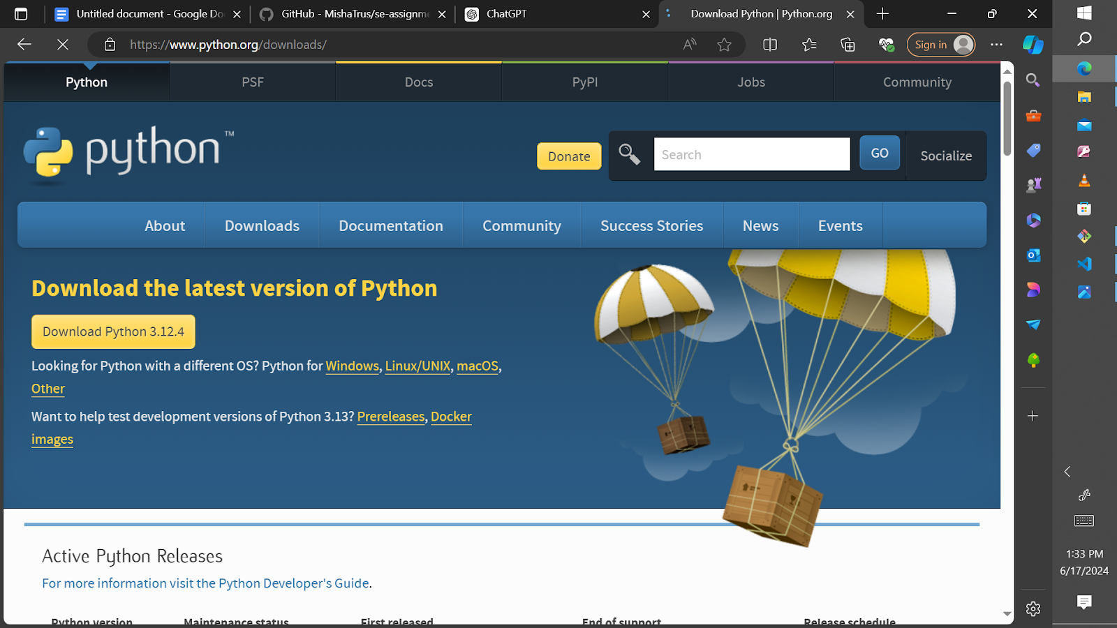
2. **Download the Installer**: Click on the download link for the latest version of Python for Windows.
3. **Run the Installer**: Open the downloaded file and follow the installation instructions, making sure to check the box "Add Python to PATH".
4. **Verify the Installation**: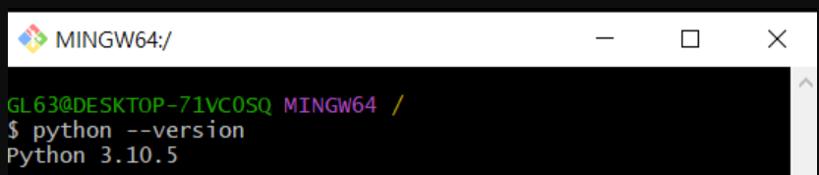

### **5. Install Package Managers (pip)**

**Verification Step**:

Verify that pip was installed with Python by running:  
sh  
Copy code  
pip --version

If pip is not installed, you can install it by downloading get-pip.py from [here](https://bootstrap.pypa.io/get-pip.py) and running:  
sh  
Copy code  
python get-pip.py

### **6. Configure a Database (MySQL)**

1. **Visit the MySQL Download Page**: Open your browser and go to [MySQL Downloads](https://dev.mysql.com/downloads/windows/installer/5.7.html).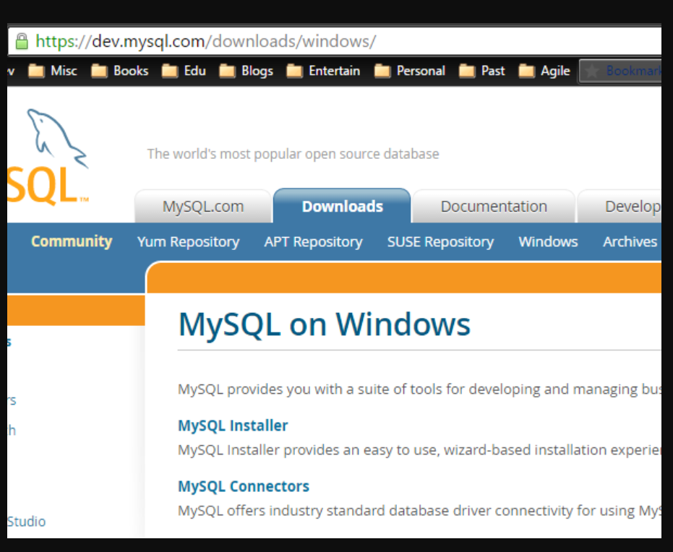
2. **Download the Installer**: Click on "Download" for the MySQL Installer.
3. **Run the Installer**: Open the downloaded file and follow the installation instructions.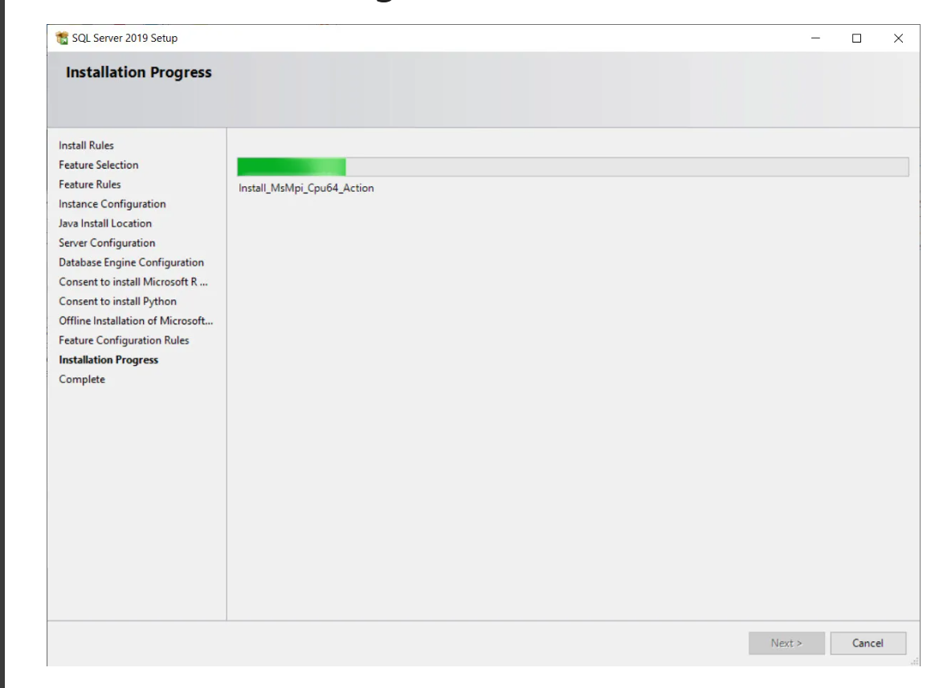
4. **Configure MySQL**:
   * Choose the setup type (Developer Default).
   * Follow the steps to configure MySQL server (root password, user accounts).
   * Complete the installation.

### **7. Set Up Development Environments and Virtualization**

**Docker Installation Guide**:

1. **Visit the Docker Download Page**: Open your browser and go to Docker Desktop.
2. **Download the Installer**: Click on the download link for Windows.
3. **Run the Installer**: Open the downloaded file and follow the installation instructions.
4. **Verify Installation**:

Open Command Prompt and type:  
sh  
Copy code  
docker --version

### **8. Explore Extensions and Plugins**

The chosen extensions for my IDE are

i) Visual Studio

1. **Open VS Code**: Click on the Extensions icon in the Activity Bar.
2. **Search for Extensions**:
   * **Python**: For Python support.
   * **GitLens**: For Git integration.
   * **Prettier**: For code formatting.
   * **ESLint**: For JavaScript/TypeScript linting.
   * **Docker**: For Docker support.

ii) Eclipse

ii) Pylance

Challenges Faced During Setup and And Employed to Overcome Them.

i) Antivirus Interference: The security software blocked the installation process.

Solution: Temporarily disabled the anti virus software during installation.

ii) Administrator Permissions: Lack of administration privilege prevented installation from proceeding

Solution: I run the installer as an administrator, by right clicking the installer file then selecting “Run as administrator

iii) Installation Errors: There were errors during installation due to corrupted installation files.

Solution: I deleted the installer file, cleared the browser cache and re-installed again.